**Title: Lab Work 1**

*Course title: Computer Graphics Laboratory*

*Course code: CSE-304*

*3rd Year 1st Semester Examination 2022*

**Date of Submission**: 28 May 2023



**Submitted to-**

**Dr. Mohammad Shorif Uddin**

*Professor*

*Department of Computer Science and Engineering*

*Jahangirnagar University*

*Savar, Dhaka-1342*

**Dr. Morium Akter**

*Associate Professor*

*Department of Computer Science and Engineering*

*Jahangirnagar University*

*Savar, Dhaka-1342*

|  |  |  |  |
| --- | --- | --- | --- |
| **Sl** | Class Roll | Exam Roll | Name |
| 01 | 361 | 202173 | Mahiyat Tanzim |

**Scan Convert a Point:**

**Source Code**

#include<stdio.h>

#include<graphics.h>

#include<math.h>

int main()

{

double x,y;

int xp,yp;

printf("Enter the coordinates of the point: ");

scanf("%lf%lf",&x,&y);

xp=floor(x);

yp=floor(y);

initwindow(1000,600);

putpixel(xp,yp,YELLOW);

getch();

return 0;

}

**Screenshot:**

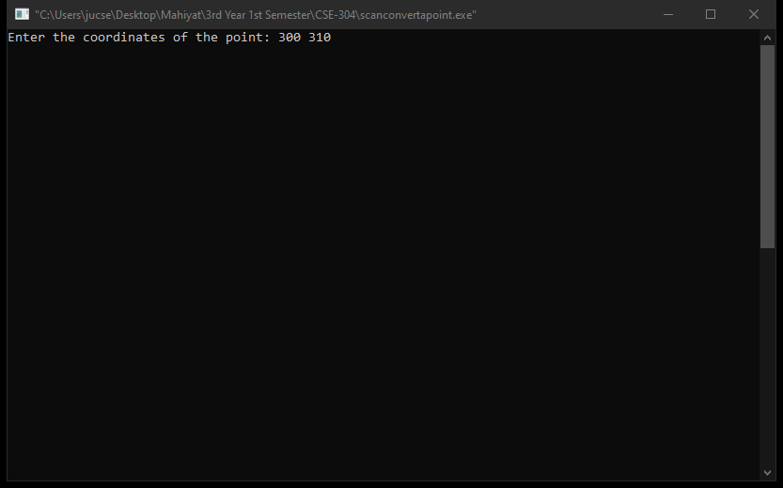

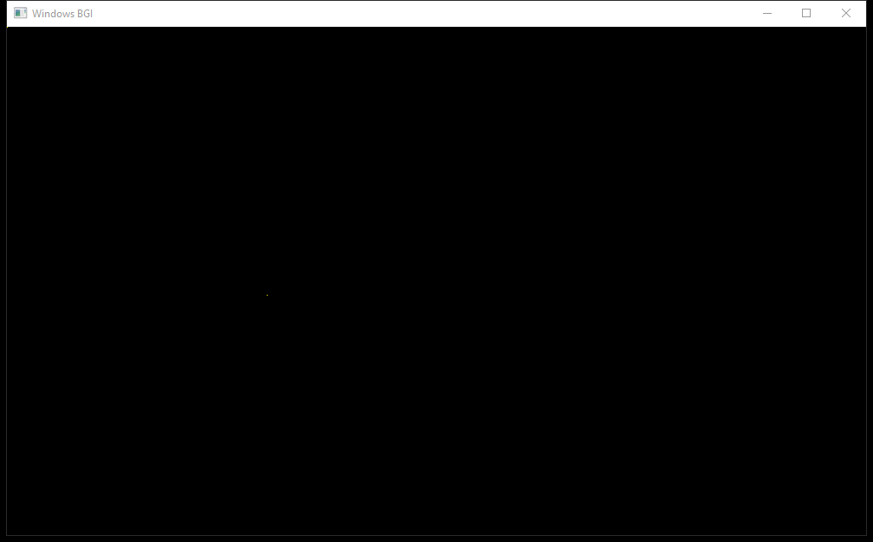

**Scan Convert a Line (DDA Algorithm):**

**Source Code:**

#include<stdio.h>

#include<graphics.h>

#include<math.h>

#include<algorithm>

using namespace std;

int main()

{

int xp1,xp2,yp1,yp2,xp,yp,dx,dy,steps,i;

double x1,x2,y1,y2,xi,yi,x,y;

printf("Enter the coordinates of the starting point of the line: ");

scanf("%lf%lf",&x1,&y1);

printf("Enter the coordinates of the ending point of the line: ");

scanf("%lf%lf",&x2,&y2);

xp1=floor(x1+0.5);

yp1=floor(y1+0.5);

xp2=floor(x2+0.5);

yp2=floor(y2+0.5);

dx=xp2-xp1;

dy=yp2-yp1;

if(abs(dx)>abs(dy))steps=abs(dx);

else steps=abs(dy);

xi=dx/(double)steps;

yi=dy/(double)steps;

x=xp1;

y=yp1;

initwindow(1000,600);

putpixel(xp1,yp1,LIGHTBLUE);

for(i=0;i<steps;i++)

{

x+=xi;

y+=yi;

xp=floor(x+0.5);

yp=floor(y+0.5);

putpixel(xp,yp,LIGHTBLUE);

}

getch();

return 0;

}

**Screenshot:**

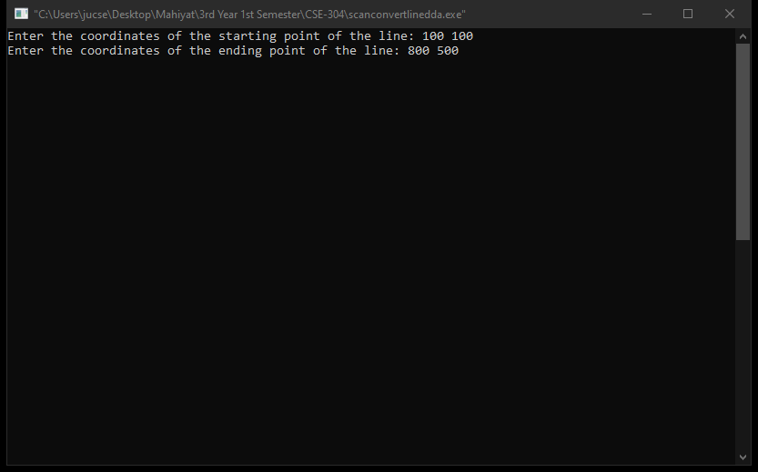

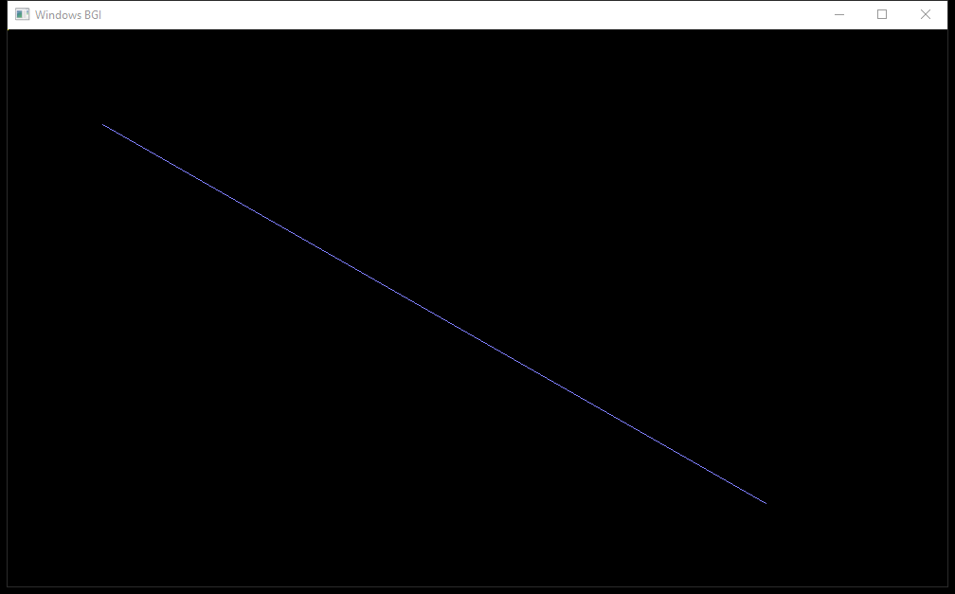

**Scan Convert a Line (Bresenham’s Algorithm):**

**Source Code:**

#include<stdio.h>

#include<graphics.h>

#include<math.h>

#include<algorithm>

using namespace std;

int main()

{

int xp,yp,ds,dt,d,xp1,xp2,yp1,yp2,dx,dy;

double x1,y1,x2,y2;

printf("Enter the coordinates of the starting point of the line: ");

scanf("%lf%lf",&x1,&y1);

printf("Enter the coordinates of the ending point of the line: ");

scanf("%lf%lf",&x2,&y2);

xp1=floor(x1+0.5);

yp1=floor(y1+0.5);

xp2=floor(x2+0.5);

yp2=floor(y2+0.5);

dx=xp2-xp1;

dy=yp2-yp1;

dt=2*(dy-dx);

ds=2*dy;

d=2*dy-dx;

initwindow(1000,600);

putpixel(xp1,yp1,LIGHTBLUE);

xp=xp1;

yp=yp1;

while(xp<xp2)

{

xp++;

if(d<0)

{

d+=ds;

}

else

{

yp++;

d+=dt;

}

putpixel(xp,yp,LIGHTBLUE);

}

getch();

return 0;

}

**Screenshot:**

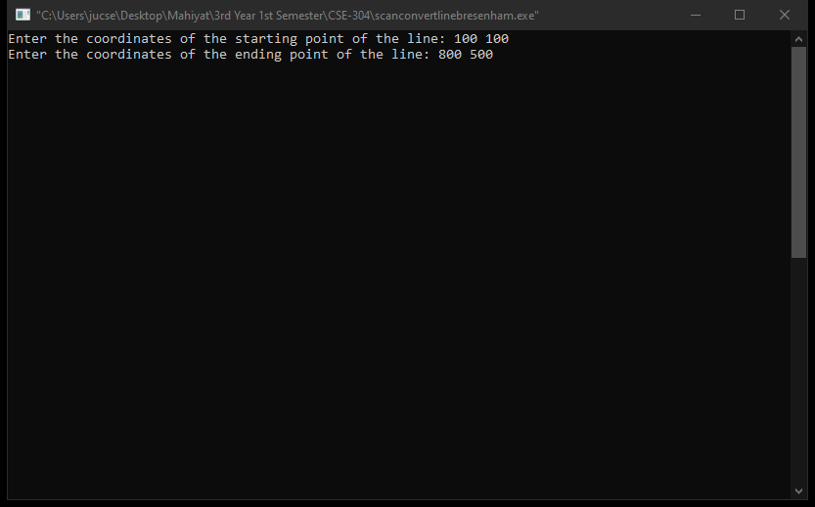



**Scan Convert a Circle (Bresenham’s Circle Algorithm):**

**Source Code:**

#include<stdio.h>

#include<graphics.h>

#include<math.h>

#include<algorithm>

using namespace std;

int main()

{

int r,x,y,d,dt,ds,h,k;

printf("Enter the coordinates of the center: ");

scanf("%d%d",&h,&k);

printf("Enter the radius of the circle: ");

scanf("%d",&r);

x=0;

y=r;

d=3-2*r;

initwindow(1000,600);

while(x<=y)

{

putpixel(x+h,y+k,LIGHTBLUE);

putpixel(y+h,x+k,LIGHTBLUE);

putpixel(-y+h,x+k,LIGHTBLUE);

putpixel(-x+h,y+k,LIGHTBLUE);

putpixel(-x+h,-y+k,LIGHTBLUE);

putpixel(-y+h,-x+k,LIGHTBLUE);

putpixel(y+h,-x+k,LIGHTBLUE);

putpixel(x+h,-y+k,LIGHTBLUE);

if(d<0)

{

dt=4*x+6;

d+=dt;

}

else

{

ds=4*(x-y)+10;

d+=ds;

y--;

}

x++;

}

getch();

return 0;

}

**Screenshot:**

